caBIG Integration Hub Test Plan
Version No: 2.2
Last Modified: 06/14/2010

Author : Harsh Marwaha
Team : caBIG Integration Hub

Client : National Cancer Institute - Center for Bioinformatics,
National Institutes of Health,
US Department of Health and Human Services

Document History

Document Location
The most current version of this document is located in Subversion.

Revision History
Version Number | Revision Date | Author | Summary of Changes
2.0 | 10/5/2009 | Harsh Marwaha | Initial
2.1 | 03/17/2010 | Harsh Marwaha | Updated for the new integrations with PO services.
2.2 | 06/14/2010 | Harsh Marwaha | Added Installation and deployment test cases
2.2 | 06/24/2010 | Harsh Marwaha | Incorporated feed back from Jessica Pritchard

Review
Name | Team/Role | Version | Date Reviewed | Reviewer Comments

Related Documents
More information can be found in the following related documents:
Document Name
caBIG Integration Hub Requirements and Specifications
CCTS Integration Smoke Test-User Guide

Table of Contents

caBIG Integration Hub Test Plan 1
Document History 2
1 Introduction 5
1.1 Scope 5
1.1.1 In Scope 5
1.1.2 Out of Scope 5
1.2 Quality Objective 5
1.2.1 Primary Objective 5
1.2.2 Secondary Objective 6
1.3 Roles and Responsibilities 6
1.3.1 Developer 6
1.3.2 QA 6
1.4 Assumptions for Test Execution 6
1.5 Definitions 7
2 Test Methodology 8
2.1 Purpose 8
2.1.1 Overview 8
2.1.2 Usability Testing 8
2.1.3 Unit Testing (Multiple) 8
2.1.4 Iteration/Regression Testing 8
2.1.5 Final release Testing 8
2.1.6 Installation and Deployment Tests 9
2.1.7 Testing completeness Criteria 9
2.2 Test Levels 9
2.2.1 Build Tests 9
2.2.2 Milestone Tests 9
2.2.3 Release Tests 10
2.3 Bug Regression 10
2.4 Bug Triage 10
2.5 Suspension Criteria and Resumption Requirements 10
2.6 Test Completeness 10
2.6.1 Standard Conditions: 10
2.6.2 Bug Reporting & Triage Conditions: 11
3 Test Deliverables 11
3.1 Test Approach 11
3.2 Test Cases 12
3.2.1 Test Cases and Requirement Traceability 12
3.3 Defect Tracking & Debugging 17
3.3.1 Testing Work flow 17
3.3.2 Defect reporting using GFORGE 17
3.4 Reports 19
3.4.1 Testing status reports 19
3.4.2 Test Final Report - Sign-Off 19
4 Resource & Environment Needs 19
4.1 Testing Tools 19
4.1.1 Tracking Tools 19
4.2 Test Environment 20
4.2.1 Hardware 20
4.2.2 Software 20
4.3 Bug Severity and Priority Definition 20
4.3.1 Severity List 20
4.3.2 Priority List 21
4.4 Bug Reporting 21
5 Terms/Acronyms 22

Introduction
caBIG Integration Hub is the software component that is primarily responsible for receiving input from various external systems, routing the input to various services that are hosted on the hub, and eventually routing the output of those services to external systems. The caBIG Integration Hub is responsible for delivering the messages reliably to target services and systems. It implements the integration scenarios for the Cancer Clinical Trial Suite (CCTS ). In addition to that it provides a number of enterprise service bus related services such as reliable transactions, payload validation and credential delegation.

Scope

In Scope
The test scope for caBIG Integration Hub includes the following:
- Testing the implemented integration use cases.
- Testing the functional and non functional requirements as implemented in caBIG Integration Hub v2.0. The scope items and requirements implemented in v2.0 of the hub are specified in the requirements and specifications document.

Out of Scope
The following areas for Audit and Logging are Out of Scope:
- Functional requirements testing for the caBIG Integration Hub Audit and Logging
- Testing of Business SOPs, disaster recovery and Business Continuity Plan.

Quality Objective

Primary Objective
A primary objective of testing application systems is to: assure that the system meets the system requirements, including quality requirements (AKA: Non-functional requirements), fit metrics for each quality requirement, satisfies the use case scenarios and maintains the quality of the product. At the end of the project development cycle, the user should find that the project has met or exceeded all expectations as documented in the requirements.

Any changes, additions, or deletions to the requirements document, Functional Specification, or Design Specification will be documented and tested at the highest level of quality allowed within the remaining time of the project and within the ability of the test team.

Secondary Objective
The secondary objective of testing application systems will be to: identify and expose all issues and associated risks, communicate all known issues to the project team, and ensure that all issues are addressed in an appropriate manner before release. This requires careful and methodical testing of the application to first ensure all areas of the system are scrutinized and, consequently, all issues (bugs) found are dealt with appropriately.

Roles and Responsibilities

Developer
An NCI-designated Cancer Center selected and funded by NCICB to participate in a specific Workspace to undertake software or solution development activities. Responsible to:
(a) Develop the system/application
(b) Develop Use cases and requirements
(c) Conduct Unit, system, regression and integration testing
(d) Support user acceptance testing

QA
An NCI-designated Cancer Center selected and funded by NCICB to undertake formal testing, and validation of application products or solutions developed by Workspace Developers. Responsible to:
(a) Contribute to Use case, requirement development through review
(b) Contribute to development and execution of the unit test scripts through review
(c) Conduct Full User Acceptance, regression, and end-to-end testing; this includes identifying test scenarios, building the test scripts, executing scripts and reporting test results

Assumptions for Test Execution

The caBIG Integration Hub testing effort has inherent dependencies on the existing NCICB products involved in the architecture and other factors such as business, software, or personnel aspects. These dependencies are documented as assumptions in this section.
- For User Acceptance testing, the Developer team has completed unit, system and integration testing and met all Requirement’s (including quality requirements).
- Test results will be reported using GForge. Failed scripts and defect list from GForge with evidence will be sent to the Developer directly.
- Use cases have been developed for Acceptance testing. Use cases are approved by test lead.
- Test scripts are developed and approved.
- GU source data – for containing complete, accurate data, and valid values with respect to HL7 v3 standards. As noted below, it is assumed that some values will be invalid and that this will allow the project to demonstrate how invalid data is handled.
- Web SSO – caGrid Authentication and Authorization: User authentication will be performed by appropriate application (C3PR, caAERS, PSC etc.). User’s grid credential will be used to connect to the caBIG Integration Hub (via Grid node). The user authorization will be performed by Grid Delegation Service by using grid Constraints for Test Execution
- Testing implemented integration scenarios will require availability and normal execution of target services. If target services are not available, then execution of the test will be deemed a success if the error is coming from a target service.
- Developer will receive consolidated list of request for test environment set up, user accounts set up, data set (actual and mock data), defect list, etc. through GForge after the initial Adopter testing kick off meeting.
- Developer will support ongoing testing activities based on priorities

Definitions
Bugs: A defect is a problem with the software, where the application or system component is not working as designed, causes unexpected behaviors, or is not functioning in accordance with the requirements.

Feature Request:
A feature request is a request to add functionality or enhance current functionality from what was designed and coded.

Features can be added as a new requirement going through the appropriate Change Management process.

Test Methodology

Purpose

Overview

The purpose of the Test Plan is to achieve the following:
- Define testing strategies for each area and sub-area to include all the functional and quality (non-functional) requirements.
- Divide Design Spec into testable areas and sub-areas. Be sure to also identify and include areas that are to be omitted (not tested) also.
- Define bug-tracking procedures.
- Identify testing risks.
- Identify required resources and related information.
- Provide testing Schedule.

Usability Testing
The caBIG Integration Hub facilitates integration in the clinical trial space. In the current version of the caBIG integration hub does not include web or user interface components directly used by users. The caBIG Integration Hub does support configuration of integration scenarios after deployment. Usability testing for the configuration aspect of the caBIG Integration Hub will not be conducted on the caBIG Integration Hub v2.0 due to time constraints.

Unit Testing (Multiple)
Unit Testing is conducted by the Developer during code development process to ensure that proper functionality and code coverage have been achieved by each developer both during coding and in preparation for acceptance into iterations testing.

Iteration/Regression Testing
At each iteration, a debriefing should be held. Specifically, the report must show that to the best degree achievable during the iteration testing phase, all identified priority 1 and 2 bugs have been communicated and addressed. At a minimum, all priority 1 and priority 2 bugs should be resolved prior to entering the beta phase.

Important deliverables required for acceptance into Final Release testing include:
- Application set up
- Installation instructions
- All documentation (beta test scripts, manuals or training guides, etc.)

Final release Testing
Assuming critical bugs are resolved during previous iteration test cycles - Throughout the Final Release test cycle, bug fixes will be focused on minor and trivial bugs (priority 3 and 4). Testing will continue its process of verifying the stability of the application through regression testing (existing known bugs, as well as existing test cases).

The milestone target of this phase is to establish that the application under test has reached a level of stability, appropriate for its usage (number users, etc.), that it can be released to the end users and caBIG community.

Installation and Deployment Tests
caBIG Integration Hub supports multiple deployment options. These deployment options are supported using configurable installation scripts. The installation and deployment tests verify that integration hub deployment on all supported platforms.

Testing completeness Criteria
The milestone target is to place the release/app (build) into production after it has been shown that the app has reached a level of stability that meets or exceeds the client expectations as defined in the Requirements, Functional Spec., and caBIG Production Standards.

Test Levels
The test categories and test levels are defined below:

Build Tests

Level 1 - Build Acceptance Tests
System will be checked to see if the proper Development Release Document plus other build related information (drop point, etc.) is in place. The objective is to determine if further testing is possible. If any Level 1 test case fails, the build is returned to developers untested.

Level 2 - Smoke Tests
The objective is to determine if further testing is possible. These test cases will emphasize breadth more than depth. All components will be touched, and every major feature should be tested briefly by the Smoke Test. If any Level 2 test case fails, the build is returned to developers untested.

Level 2a - Bug Regression Testing
Every bug that was “Open” during the previous build, but marked as “Resolved,” needs re-testing. The current build under test will need to be regression tested as well. Once the smoke test is completed regression testing can commence.

Milestone Tests

Level 3 - Critical Path Tests
Critical Path test cases must pass by the end of every 2-3 Build Test Cycles. They will not need to be tested every drop, but must be tested at least once per milestone. Thus, the Critical Path test cases must all be executed at least once during the Iteration cycle, and once during the Final Release cycle.

Release Tests

Level 4 - Standard Tests
Functional test cases may be executed multiple times with each Iteration, as they could be flagged to be included in the regression test suite after their initial execution.
Standard test cases usually include Installation, Data, GUI, and other test areas.

Bug Regression
All bugs that are at a status of ‘Resolved’, Need to be Retested” when the Testing team is notified of the new drop containing the fixes. When a bug passes regression it will be considered “Verified”. If a bug fails regression, the testing team will notify development team by entering notes into GForge. When a critical or high priority bug fails regression, the Testing team should also put out an immediate email to development. The Test Lead will be responsible for tracking and reporting to development and product management the status of regression testing.

Bug Triage

The Test Lead, Product Manager, and Development Lead should all be involved in these triage meetings. The Test Lead will provide required documentation and reports on bugs for all attendees. The purpose of the triage is to determine the type of resolution for each bug and to prioritize and determine a schedule for all “To Be Fixed Bugs’. Project Manager will then assign the bugs to the appropriate person for fixing and report the resolution of each bug back into the GForge bug tracker system. The Test Lead will be responsible for tracking and reporting on the status of all bug resolutions.

Suspension Criteria and Resumption Requirements
A bug report should be filed by the development team. After fixing the bug, the development team will follow the drop criteria (described above) to provide its latest drop for additional testing. At that time, the testing team will regress the bug, and if passes, continue testing the module.

Test Completeness
Testing will be considered complete when the following conditions have been met:

Standard Conditions:
- When testing team and Developers, agree that testing is complete, the app is stable, and the application meets functional requirements.
- Script execution of all test cases in all areas has been executed.
- Automated test cases have in all areas have been executed.
- NCI approves the test completion
- Each test area has been signed off as completed by the Test Lead.
- No ‘Critical or High’ Priority bugs that have no definable workaround remain

Bug Reporting & Triage Conditions:
- Bug find rate indicates a decreasing trend prior to Zero Bug Rate (no new priority. 1/2 bugs found).
- Bug priority distribution has changed to a steady decrease in Priority. 1 and 2 bugs discovered.
- No ‘Critial or High’ bugs that have no definable workaround remain.

Test Deliverables
Testing will provide specific deliverables during the project. These deliverables fall into three basic categories: Documents, Test Cases / Bug Write-ups, and Reports. Here is a diagram indicating the dependencies of the various deliverables:

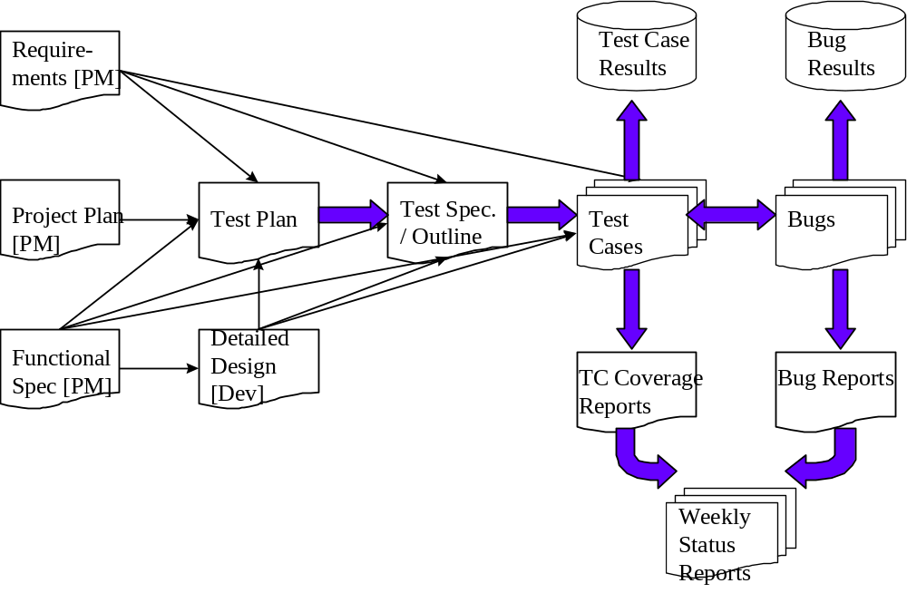

As the diagram above shows, there is a progression from one deliverable to the next. Each deliverable has its own dependencies, without which it is not possible to fully complete the deliverable.

The following page contains a matrix depicting all of the deliverables that Testing will use.

Test Approach

Integration Test Scripts
The caBIG Integration test scripts are used to test the caBIG Integration Hub. The use of these scripts is discussed in detail in the CCTS Integration Smoke test user guide. These scripts are used to send various payloads to the caBIG Integration Hub to test various scenarios. These scripts with additional configuration changes are used to create the required test scenarios.

Login
Authentication to use the caBIG Integration Hub is done using the integration test scripts. The test scripts expose properties that can be use to set the Grid environment and credentials used to authenticate to caBIG Integration Hub.

Payloads
Payloads are created to test various scenarios and verify that the test cases.

Configuration
caBIG Integration Hub will provide configuration files that enable testing of the hub software independently of the availability of target services. Configuration files are also provided for implementing specific test scenarios as needed.

Test Cases

Test Cases and Requirement Traceability
Here are some of the test cases that will be tested for the caBIG Integration Hub. The test cases are sequential in the order of dependency.

Test Cases for Integration Scenarios
The following test cases are for the integration scenarios implemented in the caBIG Integration Hub. The scenario # referred in this section traces back to the Section 2.1.1.1 of the caBIG Integration Hub Requirements and Specifications.

Test Case No | Scenario # | Features to be Tested | Test Case Description
IHUB-1 | 1.0 | Patient Laboratory data should be routed to the CTODS Grid Service. Test asynchronous invocation. | Send the patient lab data to the integration hub. Verify it is persisted in the CTODS service.
IHUB-2 | 1.0 | Patient Laboratory data should be routed to the CTODS Grid Service. Test synchronous invocation. | Send the patient lab data to the integration hub. Verify it is persisted in the CTODS service
IHUB-3 | 2.0 | Study Creation message to the PSC, caAERS, and LabViewer. | Send message and verify success route.
IHUB-4 | 2.0 | Study Creation message to the PSC, caAERS, and LabViewer. Test synchronous invocation | Send message and verify success route.
IHUB-5 | 2.0 | Study Creation message to the PSC, caAERS, and LabViewer. Test rollback. | Update url to one of the services to cause a rollback. Send message and verify rollbacks are initiated.
IHUB-6 | 2.0 | Study Creation message to the PSC, caAERS, and LabViewer. Test payload validation. | Send an invalid payload for Study creation message. A valid response would be a failure with payload validation.
IHUB-7 | 3.0 | Register Subject message to the PSC, caAERS, C3D and LabViewer. | Send Register Subject message to the integration hub and verify success route.
IHUB-8 | 3.0 | Register Subject message to the PSC, caAERS, C3D and LabViewer. Test synchronous invocation | Send Register Subject message to the integration hub and verify success route.
IHUB-9 | 3.0 | Register Subject message to the PSC, caAERS ,C3D , and LabViewer. Test rollback. | Update url to one of the services to cause a rollback. Send message and verify rollbacks are initiated.
IHUB-10 | 3.0 | Register Subject message to the PSC, caAERS, C3Dand LabViewer. Test payload validation. | Send an invalid payload for Study creation message. A valid response would be a failure with payload validation.
IHUB-11 | 4.0 | HL7v3 Lab message to the C3D Load lab service. | Send the HL7v3 t lab data to the integration hub. Verify it is received and processed by C3D.
IHUB-12 | 4.0 | HL7v3 Lab message to the C3D Load lab service. Payload validation. | Send the HL7v3 t lab data to the integration hub with invalid payload. A valid response would be a failure with payload validation.
IHUB-13 | 4.0 | HL7v3 Lab message to the C3D Load lab service. Synchronous invocation. | Send the HL7v3 t lab data to the integration hub synchronously. Verify it is received and processed by C3D.
IHUB-14 | 5.0 | HL7v3 Lab message to the caAERS Application. | Send the HL7v3 t lab data to the integration hub. Verify it is received and processed by caAERS Application.
IHUB-15 | 5.0 | HL7v3 Lab message to the caAERS Application.. Synchronous invocation. | Send the HL7v3 t lab data to the integration hub synchronously. Verify it is received and processed by C3D.
IHUB-16 | 6.0 | Adverse Event notification to the PSC application. | Send the adverse event data to the integration hub. Verify it is received and processed by the PSC Application.
IHUB-17 | 6.0 | Adverse Event notification to the PSC application. Payload validation. | Send the adverse event data with invalid payload to the integration hub. A valid response would be a failure with payload validation.
IHUB-18 | 6.0 | Adverse Event notification to the PSC application. Synchronous invocation. | Send the adverse event data to the integration hub synchronously. Verify it is received and processed by the PSC Application.
IHUB-19 | 7.0 | Person and Organization services invocation | Send the payload to invoke the getById operation on the services synchronously. Verify the results returned from the hub.  The services that will be invoked as part of this test include:  PERSON, ORGANIZATION, CLINICAL_RESEARCH_STAFF, HEALTH_CARE_FACILITY, HEALTH_CARE_PROVIDER, IDENTIFIED_ORGANIZATION, IDENTIFIED_PERSON, ORGANIZATIONAL_CONTACT, OVERSIGHT_COMMITTEE, RESEARCH_ORGANIZATION
IHUB-20 | 8.0 | Protocol and Abstraction services invocation | Send the payload to invoke the get operation on the services synchronously. Verify the results returned from the hub.  The services that will be invoked as part of this test include:  ARM,DOCUMENT,DOCUMENT_WORKFLOW_STATUS,PLANNED_ACTIVITY,STUDY_CONTACT,STUDY_DISEASE,STUDY_IND_IDE,STUDY_ONHOLD,STUDY_OUTCOME_MEASURE,STUDY_OVERALL_STATUS,STUDY_SITE_CONTACT,STUDY_SITE,STUDY_PROTOCOL,STUDY_RECRUITMENT_STATUS,STUDY_REGULATORY_AUTHORITY,STUDY_RELATIONSHIP,STUDY_RESOURCING,STUDY_SITE_ACCRUAL_STATUS
IHUB-21 | 9.0 | Invoke caTissue API asynchronously via caGrid service. | Send the payload to invoke the caTissue API asynchronously over the grid. A createParticipant message can be sent. Verify participant creation in caTissue.
IHUB-22 | 10.0 | Invoke caTissue API synchronously via caGrid service. | Send the payload to invoke the caTissue API synchronously over the grid. A createParticipant message can be sent. Verify participant creation in caTissue.
IHUB-PO-Business | 11.0 | Person and Organization business services invocation | Send the payload to invoke the following operations:  getCorrelationByIdWithEntities  getCorrelationsByIdsWithEntities  getCorrelationsByPlayerIdsWithEntities  getEntityByIdWithCorrelations  searchCorrelationsWithEntities  searchEntitiesWithCorrelations  The services that will be invoked as part of this test include:  PO_BUSINESS
IHUB-23 | 12.0 | Testing the non-grid CXF Interface to integrate with caGrid services. | Configure a bean and endpoint as given in caBIG Integration Hub Administrators Guide Section Using Grid Credentials sub-section Using Authentication Service.  Update the routing for Schedule Modification or the Load lab to CDMS scenario messages to use the new endpoint instead on one invoking the delegation service. Send a corresponding message through the CXF interface without providing a delegation EPR. The target service should be invoked.
IHUB-24 | 13.0 | Test integration with COPPA Services on a different caGrid environment then the Suite applications. | Update the caxchange.properties COPPA service urls to point to a tier that uses a different caGrid environment then the Suite applications. Configure the iHub to use secure services in two different caGrid environments. See section Invoke Services From different Grids in the Administrators Guide. Run and verify test scenario for STUDY_CREATION( uses Suite Services) and for COPPA PERSON service(uses COPPA services).

System Test Cases
The following test cases are for the integration scenarios implemented in the caBIG Integration Hub. The gforge id # referred in this section traces back to the Section 4.1.1 of the caBIG Integration Hub Requirements and Specifications.

Test Case No | Gforge Id # | Features to be Tested | Test Case Description
IHUB-S-1 | 14144 | Payload validation | Send valid payload for a service that is configured for payload validation. Verify that the message passes through the payload validation.
IHUB-S-2 | 14144 | Payload validation | Send invalid payload for a service that is configured for payload validation. Verify that the response returns the appropriate error for the payload.
IHUB-S-3 | 14144 | Payload validation | Configure a service for payload validation using the GME. Verify that payload validation works using GME for a valid payload.
IHUB-S-4 | 14144 | Payload validation | Configure a service for payload validation using the GME. Send an invalid payload. Verify that the response returns the appropriate error for the payload.
IHUB-S-5 | 22519 | Mail notification component | Configure a service for mail notifications. Verify that mail notifications are sent when the service is invoked.
IHUB-S-6 | 22684 | Transformation component | Configure a service for XSL transformations. Send a payload to the transformation service and verify the results.
IHUB-S-7 | 22799 | Non caGrid CXF Component | Send a payload to the CXF component synchronously. Verify the processing of the payload.
IHUB-S-8 | 22799 | Non caGrid CXF Component | Send a payload to the CXF component asynchronously. Verify the processing of the payload.

Installation and Deployment Test Cases
The following test cases test all the supported installation and deployment configurations for caBIG Integration Hub. The tests verify combinations of the following deployment and installation scenarios:

- Database – Support platforms include Postgres 8.2.11, Oracle 10.2 and mySQL 5.0.45. The database deployment testing assumes that the database schema and pre-requisites are created. The build and deployment automation database installation flags will be used in the following combination for this testing:
  - database.drop-schema=true
  - database.re-create=false
- Installation Mode – Options include a clean install or an upgrade of an existing install
- Log Locator Tool (LLT) Deployment – Options include deployment with or without the Log Locator tool and auditing configured
- Suite Mode – Options include installation of integration hub as part of the caBIG Clinical Trials Suite or standalone mode.

Test Case No | Database Deployment |  |  | Installation Mode |  | LLT Deployment |  | Suite Mode
Test Case No | Postgres 8.2.11 | Oracle 10.2 | mySQL 5.0.45 | Clean Install | Upgrade | LLT Not Deployed | LLT deployed | Invoked from Suite Installer | Standalone
IHUB-I-1 | X |  |  | X |  | X |  |  | X
IHUB-I-2 | X |  |  | X |  |  | X |  | X
IHUB-I-3 | X |  |  |  | X | X |  | X
IHUB-I-4 | X |  |  |  | X |  | X | X
IHUB-I-5 | X |  |  |  | X | X |  |  | X
IHUB-I-6 | X |  |  |  | X |  | X |  | X
IHUB-I-7 |  | X |  | X |  | X |  |  | X
IHUB-I-8 |  | X |  | X |  |  | X |  | X
IHUB-I-9 |  | X |  |  | X | X |  | X
IHUB-I-10 |  | X |  |  | X |  | X | X
IHUB-I-11 |  | X |  |  | X | X |  |  | X
IHUB-I-12 |  | X |  |  | X |  | X |  | X
IHUB-I-13 |  |  | X | X |  | X |  |  | X
IHUB-I-14 |  |  | X | X |  |  | X |  | X
IHUB-I-15 |  |  | X |  | X | X |  |  | X
IHUB-I-16 |  |  | X |  | X |  | X |  | X
IHUB-I-17 |  |  | X |  | X | X |  | X
IHUB-I-18 |  |  | X |  | X |  | X | X

Defect Tracking & Debugging

Testing Work flow
The below work flow illustrates the testing work flow process for Developers and Adopters for User Acceptance and End to End testing.
Note the yellow highlighted process where the Adopter is required to directly send defect list with evidence to the Developer. Similarly, Developer is required to confirm directly with the Adopter after bug fixes along with updating on the GForge.
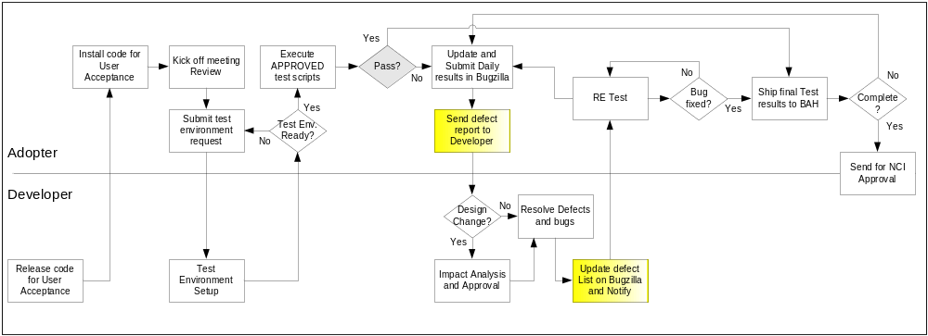

Defect reporting using GFORGE
ALL defects should be logged using ‘GFORGE’, to address and debug defects. Adopters are also requested to send a daily defect report to the developer. Developers will update the defect list on G Forge and notify the requester after the defect has been resolved.
Developers and Adopters are required to request an account on G Forge for the relative workspace. Debugging should be based on Priority –Critical > High > Medium > Low, these priorities are set by the Adopters and are based on how critical is the test script in terms of dependency and mainly based on use case scenario.
The screen shot below displays ‘Add new Defect’ screen, fields marked with ( * ) are mandatory fields and Adopters should also upload the evidence file for all the defects listed.

All High priority defects should be addressed within 1 day of the request and resolved/closed within 2 days of the initial request
All Medium priority defects should be addressed within 2 days of the request and resolved/closed within 4 days of the initial request
All Low priority defects should be resolved/closed no later than 5 days of the initial request.

G Forge URL - http://gforge.nci.nih.gov
User may either search for workspace or select from list of recent project from the bottom right side of the window. E.g. searching for ‘caTIES’.
At the workspace, the user can request Administrators to setup their user account for that workspace.
After login, user can select ‘Tracker’ tab to ‘Submit New’ defect. User can add defect info. As shown in below screen.

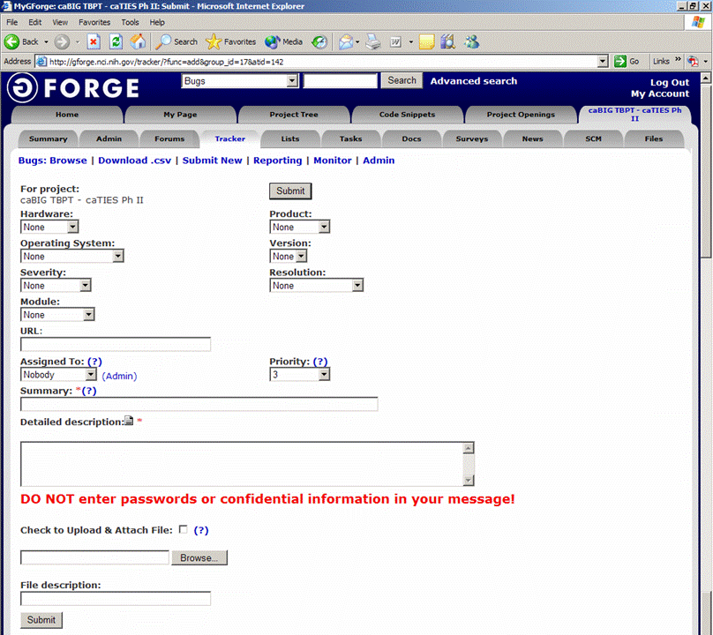
Field Comments
Hardware - List the testing environment hardware. e.g. PC, MAC
Product - Add default to workspace name e.g. caTIES
Operating System - Win 98, Win 2k, Win XP, MAC, etc.
Version - Application version
Severity - If it is an enhancement or a bug with minor to major severity that may not interfere with further testing or completely block any future testing efforts.
Resolution - Only DEVELOPER will update based on the defect
Module - For an application with multiple modules, select appropriate module for the defect reported.
URL - Add URL if any
Assigned to - To be updated by Developer, for whom the ticket is assigned to
Priority - Set a priority based on severity
Summary - Summary of the defect, bug or issue
Detailed Desc. - Details of the defect, bug or issue
Upload file - Attach evidence file
Submit - Submit the bug ticket

Reports
The Test Lead will be responsible for writing and disseminating the following reports to appropriate project personnel as required.

Testing status reports
A weekly or bi-weekly status report will be provided by the Test Lead to project personnel. This report will summarize weekly testing activities, issues, risks, bug counts, test case coverage, and other relevant metrics.

Test Final Report - Sign-Off
A Final Test Report will be issued by the Test Lead. It will certify as to the extent to which testing has actually completed (test case coverage report suggested), and an assessment of the product’s readiness for Release to Production.

Resource & Environment Needs

Testing Tools

Tracking Tools
GForge bug tracker is used by caBIG to enter and track all bugs and project issues. The Test Lead is responsible for maintaining the GForge database.

Test Environment

Hardware
The following is the hardware requirement for testing caXchange Audit and Logging
- 2G Hard Disk Space
- 2G Ram
- Linux-compatible CPU

Operating System | Linux
Database | MySQL 5.0.45
Java | 1.5.10
Container | Servicemix 3.3.1 and Tomcat 5.5.20
Build Tools | Maven 2.0.8

Software
In addition to the application and any other customer specified software, the following list of software should be considered a minimum:

Software/Version:
==========================
Tomcat 5.5.20- secure
MySQL (database)
Globus 4.0.3 (embedded in tomcat)
ServiceMix 3.3.1(container)
Maven 2.0.8
Linux (OS)

Bug Severity and Priority Definition
Bug Severity and Priority fields are both very important for categorizing bugs and prioritizing if and when the bugs will be fixed. The bug Severity and Priority levels will be defined as outlined in the following tables below. Testing will assign a severity level to all bugs. The Test Lead will be responsible to see that a correct severity level is assigned to each bug.

The Test Lead, Development Lead and Program Manager will participate in bug review meetings to assign the priority of all currently active bugs. This meeting will be known as “Bug Triage Meetings”. The Test Lead is responsible for setting up these meetings on a routine basis to address the current set of new and existing but unresolved bugs.

Severity List
The tester entering a bug into GForge is also responsible for entering the bug Severity.

Severity ID |  | Severity Level | Severity Description
1 |  | Critical | The module/product crashes or the bug causes non-recoverable conditions. System crashes, GP Faults, or database or file corruption, or potential data loss, program hangs requiring reboot are all examples of a Severity. 1 bug.
2 |  | Major | Major system component unusable due to failure or incorrect functionality. Severity. 2 bugs cause serious problems and include the following:  - lack of functionality  - Insufficient or unclear error messages that can have a major impact to the user  - Prevents other areas of the app from being tested  Severity. 2 bugs can have a work around, but the work around should not be inconvenient or difficult.
3 |  | Normal | Incorrect functionality of component or process. There is a simple work around for the bug if it is Severity. 3.
4 |  | Minor | Documentation errors or signed off severity 3 bugs.
5 | Trivial |  |  | Enhancements/ Good to have features incorporated- just are out of the current scope.

Priority List
Priority ID | Priority Level | Priority Description
5 | Must Fix | This bug must be fixed immediately; the product cannot ship with this bug.
4 | Should Fix | These are important problems that should be fixed as soon as possible. It would be an embarrassment to the company if this bug shipped.
3 | Fix When Have Time | The problem should be fixed within the time available. If the bug does not delay shipping date, then fix it.
2 | Low Priority | It is not important (at this time) that these bugs be addressed. Fix these bugs after all other bugs have been fixed.
1 | Trivial | Enhancements/ Good to have features incorporated- just are out of the current scope.

Bug Reporting
Testing team recognizes that the bug reporting process is a critical communication tool within the testing process. Without effective communication of bug information and other issues, the development and release process will be negatively impacted.

The Test Lead will be responsible for managing the bug reporting process. Testing’s standard bug reporting tools and processes will be used. GForge is the company-wide standard Bug Logging / Tracking tool. Testing and development will enter their data into the GForge database following the field entry definitions defined below.

Terms/Acronyms

TERM/ACRONYM | DEFINITION
API | Application Program Interface
BAH | Booz Allen Hamilton
BCP | Business Continuity Plan
CAT | Client Acceptance Testing
End-to End Testing | Tests user scenarios and various path conditions by verifying that the system runs and performs tasks accurately with the same set of data from beginning to end, as intended.
ER;ES | Electronic Records; Electronic Signatures
N/A | Not Applicable
NCI | National Cancer Institute
QA | Quality Assurance
RTM | Requirements Traceability Matrix
SME | Subject Matter Expert
SOP | Standard Operating Procedure
TBPT | Tissue Bank and Pathology Tools
TBD | To Be Determined
TSR | Test Summary Report
CTODS | Clinical Trials Object Data System

